

**Practical File**

**SHIN CAKES**

**WEB APPLICATIONS (803)**

Submitted By:-

Name: Nakul Uppal

Class: XII C(NM)

Roll No:13665998

Submitted To:-

Mr. Amandeep Singh



SOURCE CODE :- HOME PAGE

          <!DOCTYPE html>

<html lang="en">

<head>

    <meta charset="UTF-8">

    <meta http-equiv="X-UA-Compatible" content="IE=edge">

    <meta name="viewport" content="width=device-width, initial-scale=1.0">

    <title>page1</title>

    <link rel="stylesheet" href="style1.css">

    <link rel="stylesheet" href="anime.css">

    <style>

      @keyframes roundi {

          from{

              border-color:red;

}

          to{

              border-color: yellow;

          }

      }

        @import url('https://fonts.googleapis.com/css2?family=Lobster&display=swap');

 </style>

</head>

<body >

<header>

    <nav>

        <ul class="logohead">

        <div>

<li style=" border:10px solid yellow ;border-radius: 25.5px; margin:20px;padding: 10px;

position:static;animation:roundi 5s infinite;" ><img src="img/logo.jpg" alt="LOGO" width="192px">

            </li>

        </div>

            <div> <li id="center" class="fe"><a href="page1.html"> Home </a> </li></div>

          <div><li class="fe"><a href="explore.html"> Explore Us</a> </li></div>

          <div> <li class="fe"><a href="feedback.html" >Feedback</a></li></div>

        </ul>

    </nav>

</header>

<br><br> <br>

<main>

     <section class="jankari">

        <p style="text-align:center">Order cakes online and have them delivered at your doorstep, at your own desired time.At our pastry

             kitchen in SATNAMPURA, our master group of dough punchers delivers an excellent scope of

             brilliant bread, baked goods, and sweet shop. Brought into the world with flour on their fingers,

             ages of our SHIN CAKES group convey their instilled energy for heating to work regular, to keep

             on being at the front line of item advancement, and guarantee that there is a strong future for

             genuine bread made by genuine bakers.<BR>

            "BAKE WITH LOVE"</p>

     </section>

<br><br> <br>

     <div class="pics">

         <br>

               <div class="cake">

                <br>

              <a href="cake.html"> &nbsp &nbsp &nbsp &nbsp<img src="img/RandomCakePic.jpg" alt="cake pic" width="200px" height="200px"></a>

                <h2> &nbsp &nbsp !--CAKES--!</h2>

            </div>    <br><br>

            <div class="cupcakes">

                <br>

                <a href="cupcakes.html"> &nbsp &nbsp &nbsp &nbsp&nbsp &nbsp&nbsp &nbsp&nbsp &nbsp<img src="img/RandomCupCakePic.jpg" alt="cupcake pic" width="200px" height="200px"></a>

                <h2> &nbsp &nbsp !--CUP-CAKES--!</h2>

            </div>    <br><br>

            <div class="extras">

                <br>

                <a href="extra.html"> &nbsp &nbsp &nbsp&nbsp &nbsp&nbsp &nbsp&nbsp &nbsp &nbsp<img src="img/RandomExtraPic.jpg" alt="extra pic" width="200px" height="200px"></a>

                <h2> &nbsp &nbsp !--EXTRAS--!</h2>

            </div>    <br><br>

     </div>

</main>

<footer>

    <div class="box1">

        <div class="box2">

       </div>

</div>

</footer>

</body>

</html>

OUTPUT:-HOMEPAGE

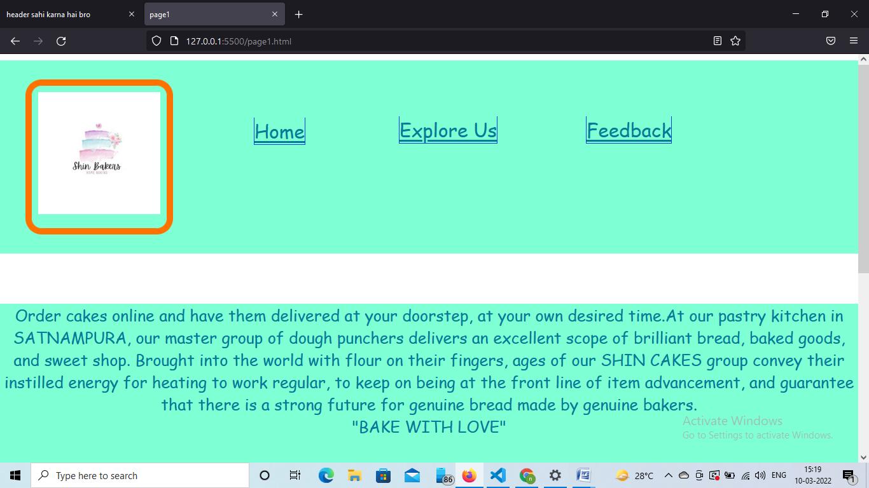

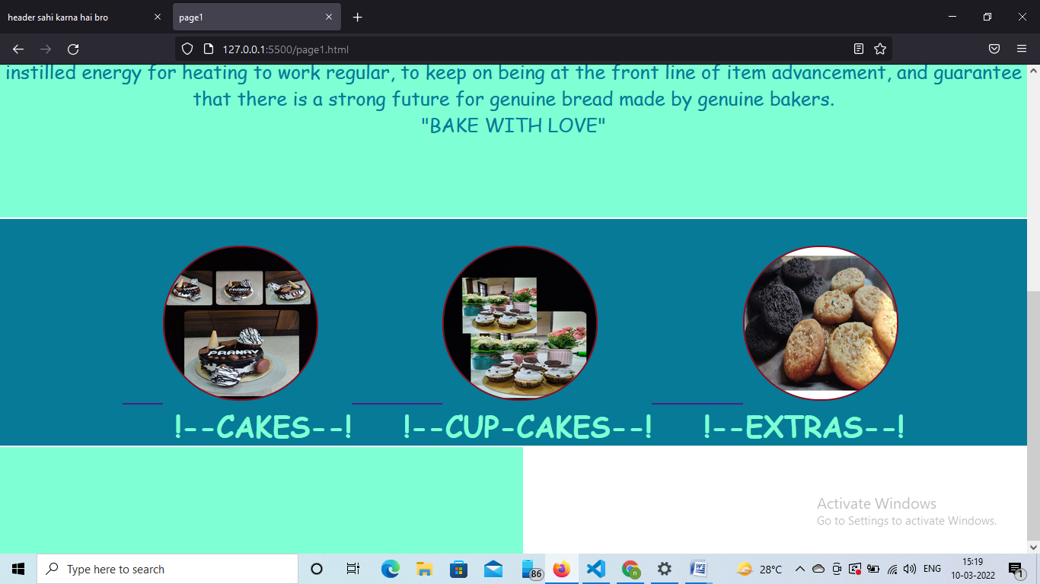

SOURCE CODE OF STYLE1(STYLESHEET):-

{

margin: 0;

padding:0;

font-family: 'Lobster', cursive;

overflow: visible;

}

.fe{

    width: 217px;

        height: 151px;

  justify-content:center;

}

.pic{

    background-color:#067a97;

    color:aquamarine;

    height: auto;

    width: auto;

}

    .pics{

        border-top:2px solid white;

    background-color:#067a97;

    color:aquamarine;

    display: flex;

    height: auto;

    width: auto;

    justify-content: center;

}

.pics img,.pic img{

    border: 2px solid #970619;

    border-radius: 100px;

}

.logohead{

    margin:10px;

    padding:10px ;

    list-style: none;

    display:flex;

    position: relative;

    align-items: center;

    gap: 5px;

}

.logohead li{

    margin: 6px;

    padding: 30px;

   left: 1120px;

   top: -9px;

    font-size: 40px;

}

#center{

position: relative;

left: 66px;

top:2px;

}

header{

    background-color: aquamarine;

}

header nav ul li a{

    border:1px solid rgb(6, 64, 224);

    border-top: none;

     justify-content: center ;

    color: #067a97;

    font-size: 30px;

}

main{

    background-color: aquamarine;

    color: #067a97;

    font-size: 25px;

}

footer{

    height: 20vh;

    color: #067a97;

}

.box2 a img{

    position:relative;

    top: 20px;

    left: 15px;

}

SOURCE CODE OF CAKE (MENU):-

<!DOCTYPE html>

<html lang="en">

<head>

    <meta charset="UTF-8">

    <meta http-equiv="X-UA-Compatible" content="IE=edge">

    <meta name="viewport" content="width=device-width, initial-scale=1.0">

    <title>Cakes</title>

    <link rel="stylesheet" href="style1.css">

    <link rel="stylesheet" href="anime.css">

    <style>

        @keyframes roundi {

            from{

                border-color: yellow;

            }

            to{

                border-color: rgb(247, 51, 17);

            }

        }

          @import url('https://fonts.googleapis.com/css2?family=Lobster&display=swap');

   </style>

</head>

<body>

    <header>

        <nav>

            <ul class="logohead">

            <div>

                <li style=" border:10px solid yellow ;border-radius: 25.5px; margin:20px;padding: 10px;

                position:static;animation:roundi 5s infinite;" ><img src="img/logo.jpg" alt="LOGO" width="192px">

                </li>

            </div>

                <div> <li id="center" class="fe"><a href="page1.html"> Home </a> </li></div>

              <div><li class="fe"><a href="explore.html"> Explore Us</a> </li></div>

              <div> <li class="fe"><a href="feedback.html" >Feedback</a></li></div>

            </ul>

        </nav>

    </header>

    <br><br> <br>

   <main>

         <div class="pic">

             <br>

              <div class="cakes">

                   <br>

                &nbsp &nbsp &nbsp &nbsp<img src="img/c1.jpg" alt="c1 pic" width="200px" height="200px">

                   <h2> &nbsp &nbsp Ferero Rochel Delicious++  &nbsp &nbsp&nbsp &nbsp   &nbsp &nbsp&nbsp &nbsp&nbsp

                    &nbsp &nbsp&nbsp &nbsp&nbsp &nbsp &nbsp  650.00/-</h2>

               </div>    <br><br>

               <div class="cakes">

                   <br>

                    &nbsp &nbsp &nbsp &nbsp<img src="img/c2.jpg" alt="c2 pic" width="200px" height="200px">

                   <h2> &nbsp &nbsp  Choclate Rasberry Crunch  &nbsp &nbsp&nbsp &nbsp   &nbsp &nbsp&nbsp &nbsp&nbsp

                    &nbsp &nbsp&nbsp &nbsp&nbsp &nbsp &nbsp  750.00/-</h2>

               </div>    <br><br>

               <div class="cakes">

                   <br>

                   &nbsp &nbsp &nbsp &nbsp<img src="img/c3.jpg" alt="c3 pic" width="200px" height="200px">

                   <h2> &nbsp &nbsp  Valentine Delight Rose  &nbsp &nbsp&nbsp &nbsp   &nbsp &nbsp&nbsp &nbsp&nbsp

                    &nbsp &nbsp&nbsp &nbsp&nbsp &nbsp &nbsp  700.00/-</h2>

               </div>    <br><br>

      </div>

     <div class="pic">

            <br>

               <div class="cakes"><div class="cakes">

                <br>

             &nbsp &nbsp &nbsp &nbsp<img src="img/c4.jpg" alt="c4 pic" width="200px" height="200px">

                <h2> &nbsp &nbsp  Tiny Dinasaurs Jumbo  &nbsp &nbsp&nbsp &nbsp   &nbsp &nbsp&nbsp &nbsp&nbsp

                    &nbsp &nbsp&nbsp &nbsp&nbsp &nbsp &nbsp  650.00/-</h2>

            </div>    <br><br>

            <div class="cakes">

                <br>

                 &nbsp &nbsp &nbsp &nbsp<img src="img/c5.jpg" alt="c5 pic" width="200px" height="200px">

                <h2> &nbsp &nbsp  Laddu Gopal Cake  &nbsp &nbsp&nbsp &nbsp   &nbsp &nbsp&nbsp &nbsp&nbsp

                    &nbsp &nbsp&nbsp  &nbsp&nbsp &nbsp&nbsp &nbsp&nbsp &nbsp &nbsp  650.00/-</h2>

            </div>    <br><br>

            <div class="cakes">

                <br>

                &nbsp &nbsp &nbsp &nbsp<img src="img/c6.jpg" alt="c6 pic" width="200px" height="200px">

                <h2> &nbsp &nbsp  Triple X Chocolate Lover &nbsp &nbsp&nbsp  &nbsp&nbsp&nbsp   &nbsp &nbsp&nbsp &nbsp&nbsp

                    &nbsp &nbsp&nbsp &nbsp&nbsp &nbsp &nbsp  700.00/-</h2>

            </div>    <br><br>

     </div>

     <div class="pic">

         <br>

            <div class="cakes">

                <br>

                 &nbsp &nbsp &nbsp &nbsp<img src="img/c7.jpg" alt="c7 pic" width="200px" height="200px">

                <h2> &nbsp &nbsp  Chocolaty Nation  &nbsp &nbsp&nbsp &nbsp   &nbsp &nbsp&nbsp &nbsp&nbsp

                    &nbsp &nbsp&nbsp &nbsp&nbsp &nbsp &nbsp &nbsp  600.00/-</h2>

            </div>

            <div class="cakes">

                <br><br>

                &nbsp &nbsp &nbsp &nbsp<img src="img/c8.jpg" alt="c8 pic" width="200px" height="200px">

                <h2> &nbsp &nbsp  Dracula Black Forest  &nbsp &nbsp&nbsp &nbsp   &nbsp &nbsp&nbsp &nbsp&nbsp

                    &nbsp &nbsp&nbsp &nbsp&nbsp &nbsp &nbsp  550.00/-</h2>

            </div>    <br><br>

        </div>

    </main>

    <footer>

        <div class="box1">

            <div class="box2">

              <a href="page1.html"><img src="img/button.jpg" alt="button back" width="100px" height="100px"></a>

           </div>

    </div>

    </footer>

</body>

</html>

OUTPUT OF CAKE (MENU):-

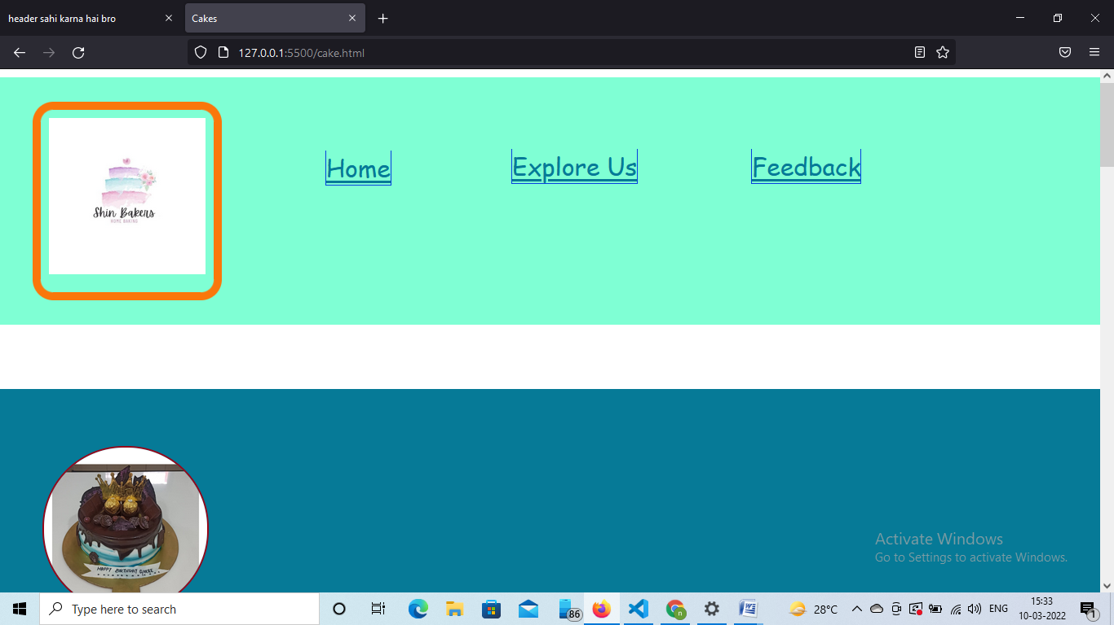

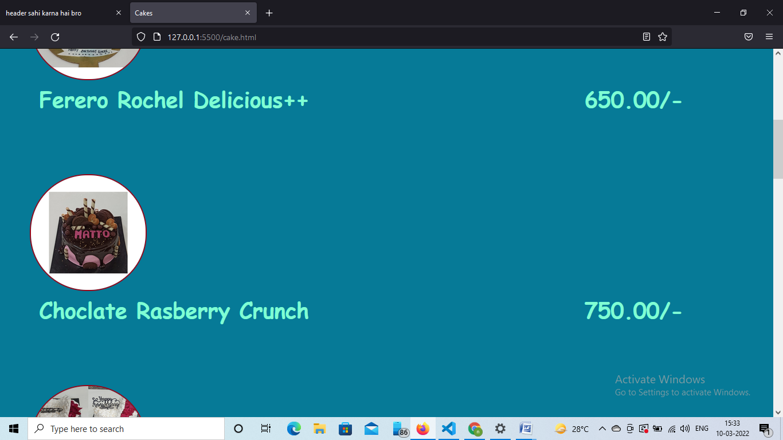

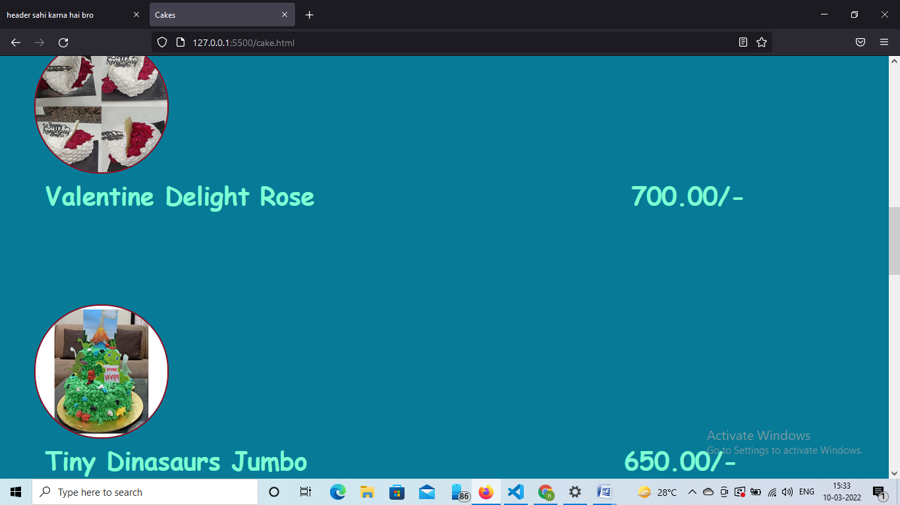

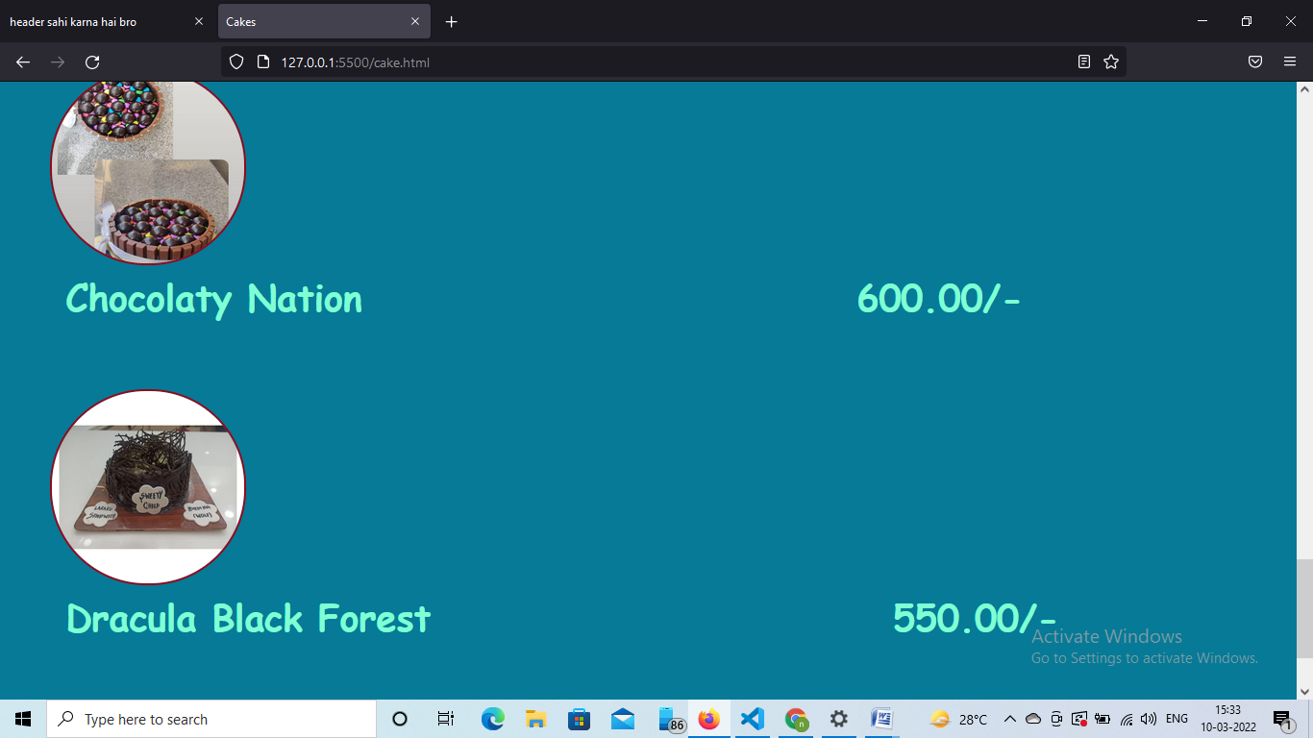

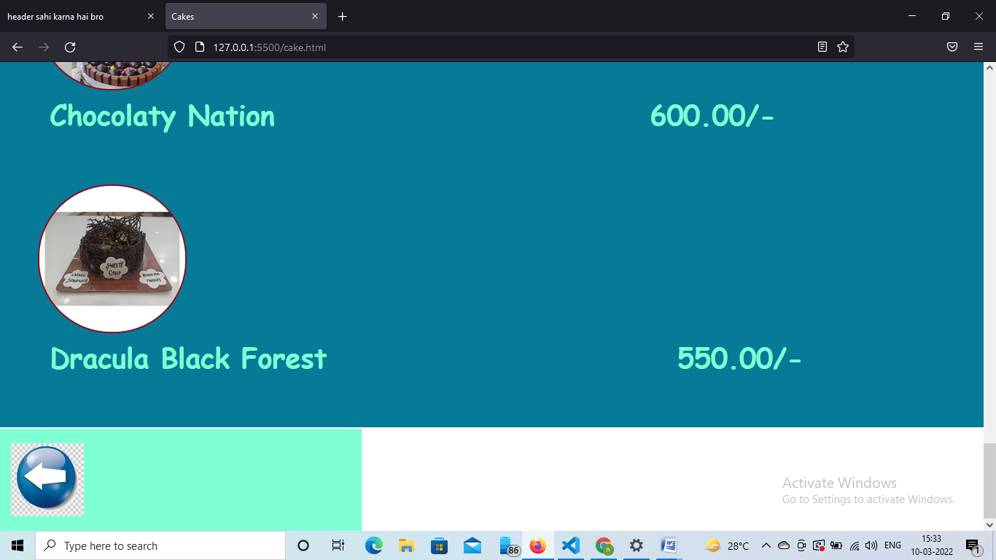

SOURCE CODE OF CUP-CAKES (MENU):-

<!DOCTYPE html>

<html lang="en">

<head>

    <meta charset="UTF-8">

    <meta http-equiv="X-UA-Compatible" content="IE=edge">

    <meta name="viewport" content="width=device-width, initial-scale=1.0">

    <title>Document</title>

    <link rel="stylesheet" href="style1.css">

    <link rel="stylesheet" href="anime.css">

    <style>

        @keyframes roundi {

            from{

                border-color: yellow;

            }

            to{

                border-color: rgb(247, 51, 17);

            }

        }

          @import url('https://fonts.googleapis.com/css2?family=Lobster&display=swap');

   </style>

</head>

<body>

    <header>

        <nav>

            <ul class="logohead">

            <div>

                <li style=" border:10px solid yellow ;border-radius: 25.5px; margin:20px;padding: 10px;

                position:static;animation:roundi 5s infinite;" ><img src="img/logo.jpg" alt="LOGO" width="192px">

                </li>

            </div>

                <div> <li id="center" class="fe"><a href="page1.html"> Home </a> </li></div>

              <div><li class="fe"><a href="explore.html"> Explore Us</a> </li></div>

              <div> <li class="fe"><a href="feedback.html" >Feedback</a></li></div>

            </ul>

        </nav>

    </header>

    <br><br> <br>

    <main>

        <div class="pic">

            <br>

             <div class="cakes">

                  <br>

               &nbsp &nbsp &nbsp &nbsp<img src="img/cc1.jpg" alt="c1 pic" width="200px" height="200px">

                  <h2> &nbsp &nbsp Walnut Choco Drycake  &nbsp &nbsp&nbsp &nbsp   &nbsp &nbsp&nbsp &nbsp&nbsp

                   &nbsp &nbsp&nbsp &nbsp&nbsp &nbsp &nbsp  300.00/-</h2>

              </div>    <br><br>

              <div class="cakes">

                  <br>

                   &nbsp &nbsp &nbsp &nbsp<img src="img/cc2.jpg" alt="cc2 pic" width="200px" height="200px">

                  <h2> &nbsp &nbsp  Oreo Cupcakes &nbsp &nbsp&nbsp &nbsp   &nbsp &nbsp&nbsp &nbsp&nbsp

                   &nbsp &nbsp&nbsp &nbsp&nbsp &nbsp &nbsp  350.00/-</h2>

              </div>    <br><br>

              <div class="cakes">

                  <br>

                  &nbsp &nbsp &nbsp &nbsp<img src="img/cc3.jpg" alt="cc3 pic" width="200px" height="200px">

                  <h2> &nbsp &nbsp  Mother's Day Special CupCake  &nbsp &nbsp&nbsp &nbsp   &nbsp &nbsp&nbsp &nbsp&nbsp

                   &nbsp &nbsp&nbsp &nbsp&nbsp &nbsp &nbsp  400.00/-</h2>

              </div>    <br><br>

     </div>

    <div class="pic">

           <br>

              <div class="cakes"><div class="cakes">

               <br>

            &nbsp &nbsp &nbsp &nbsp<img src="img/cc4.jpg" alt="cc4 pic" width="200px" height="200px">

               <h2> &nbsp &nbsp  Choco Hot SpringX100  &nbsp &nbsp&nbsp &nbsp   &nbsp &nbsp&nbsp &nbsp&nbsp

                   &nbsp &nbsp&nbsp &nbsp&nbsp &nbsp &nbsp  250.00/-</h2>

           </div>    <br><br>

           <div class="cakes">

               <br>

                &nbsp &nbsp &nbsp &nbsp<img src="img/cc5.jpg" alt="c5 pic" width="200px" height="200px">

               <h2> &nbsp &nbsp  Vanila Dry Fruit Drycake  &nbsp &nbsp&nbsp &nbsp   &nbsp &nbsp&nbsp &nbsp&nbsp

                   &nbsp &nbsp&nbsp  &nbsp&nbsp &nbsp&nbsp &nbsp&nbsp &nbsp &nbsp  200.00/-</h2>

           </div>    <br><br>

           <div class="cakes">

               <br>

               &nbsp &nbsp &nbsp &nbsp<img src="img/cc6.jpg" alt="c6 pic" width="200px" height="200px">

               <h2> &nbsp &nbsp  Chocolate Drycake &nbsp &nbsp&nbsp  &nbsp&nbsp&nbsp   &nbsp &nbsp&nbsp &nbsp&nbsp

                   &nbsp &nbsp&nbsp &nbsp&nbsp &nbsp &nbsp  250.00/-</h2>

           </div>    <br><br>

    </div>

    <div class="pic">

        <br>

           <div class="cakes">

               <br>

                &nbsp &nbsp &nbsp &nbsp<img src="img/cc7.jpg" alt="c7 pic" width="200px" height="200px">

               <h2> &nbsp &nbsp  Brownie Nation  &nbsp &nbsp&nbsp &nbsp   &nbsp &nbsp&nbsp &nbsp&nbsp

                   &nbsp &nbsp&nbsp &nbsp&nbsp &nbsp &nbsp &nbsp  350.00/-</h2>

           </div>

           <div class="cakes">

               <br><br>

               &nbsp &nbsp &nbsp &nbsp<img src="img/cc8.jpg" alt="c8 pic" width="200px" height="200px">

               <h2> &nbsp &nbsp  Choco Dryfruit Sinner  &nbsp &nbsp&nbsp &nbsp   &nbsp &nbsp&nbsp &nbsp&nbsp

                   &nbsp &nbsp&nbsp &nbsp&nbsp &nbsp &nbsp  350.00/-</h2>

           </div>    <br><br>

       </div>

   </main>

   <footer>

    <div class="box1">

        <div class="box2">

          <a href="page1.html"><img src="img/button.jpg" alt="button back" width="100px" height="100px"></a>

       </div>

</div>

</footer>

</body>

</html>

OUTPUT OF CUP-CAKES (MENU):-

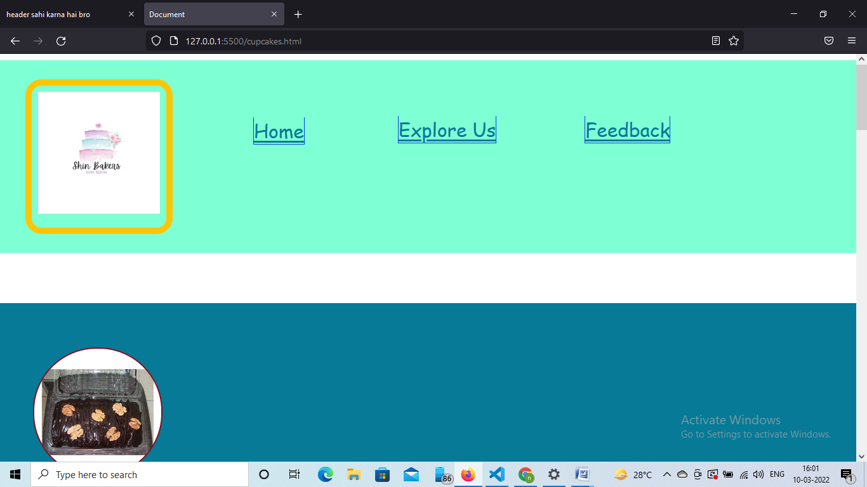

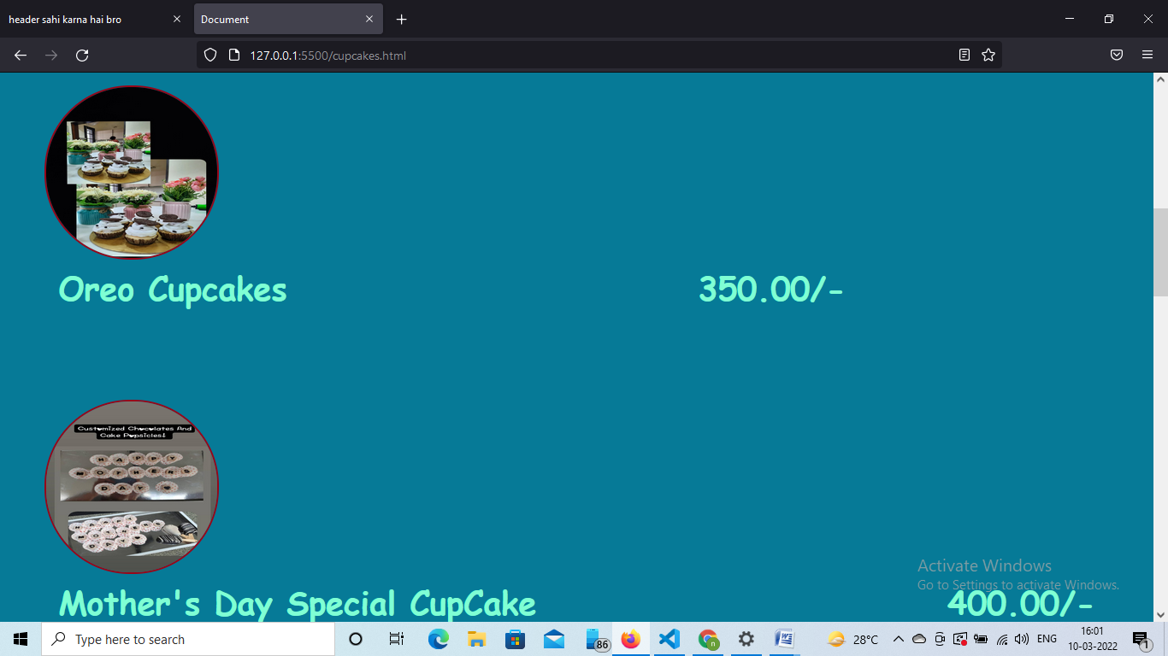

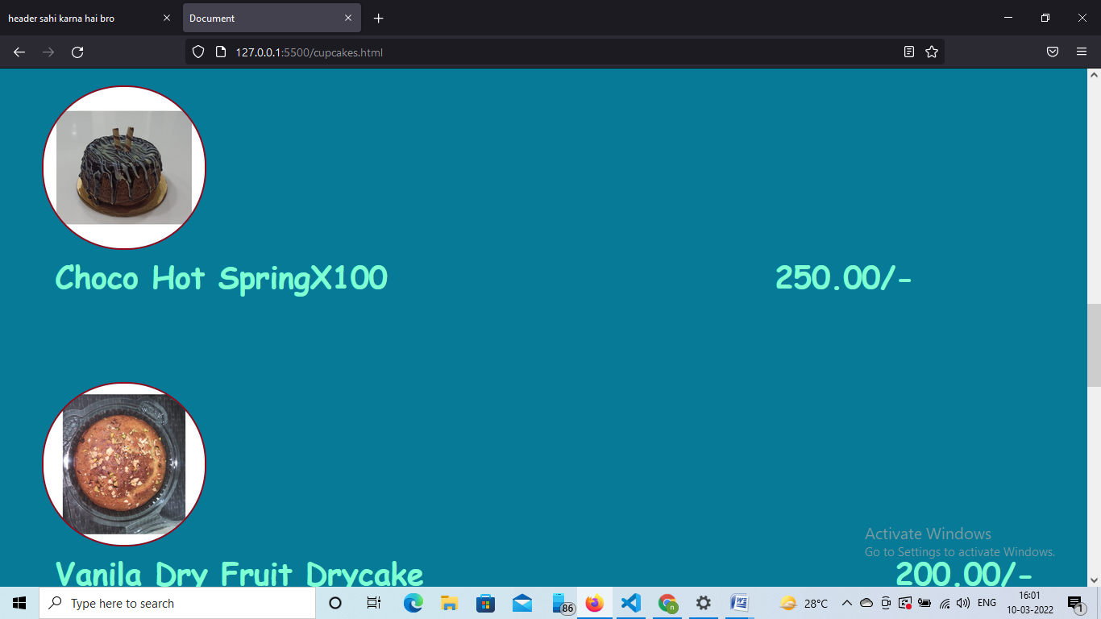

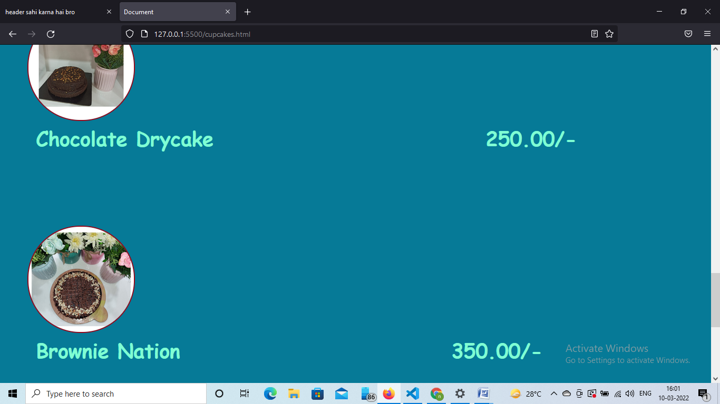

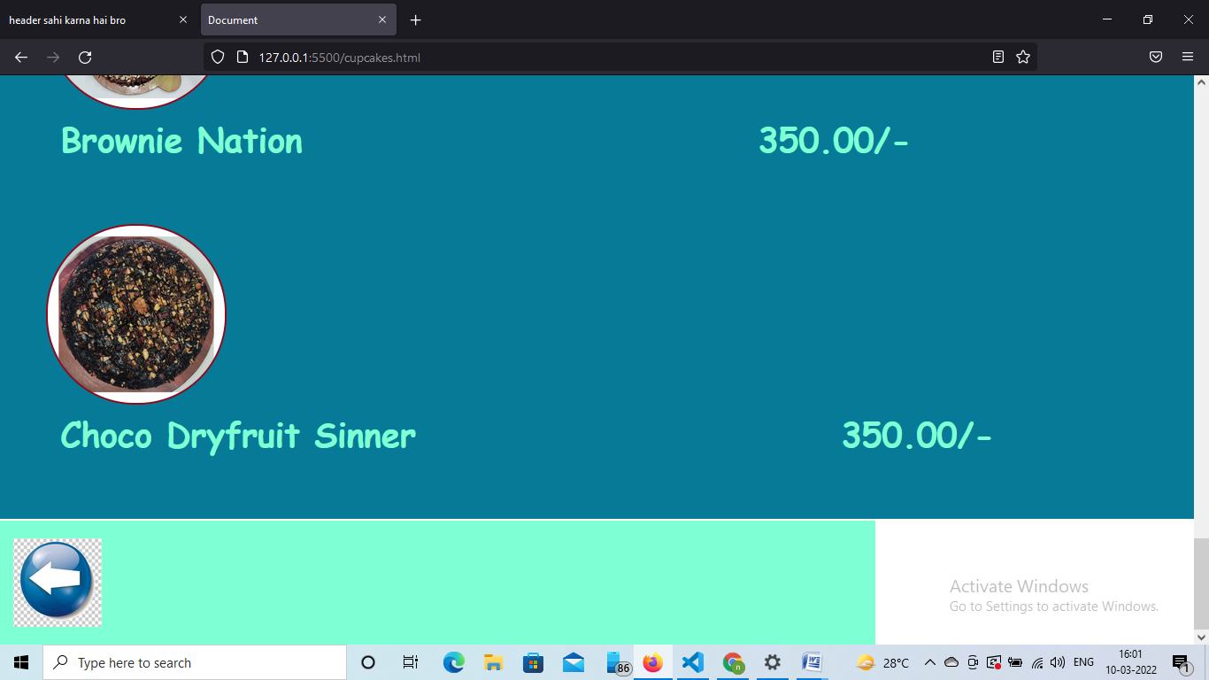

SOURCE CODE OF EXTRAS:-

<!DOCTYPE html>

<html lang="en">

<head>

    <meta charset="UTF-8">

    <meta http-equiv="X-UA-Compatible" content="IE=edge">

    <meta name="viewport" content="width=device-width, initial-scale=1.0">

    <title>Document</title>

    <link rel="stylesheet" href="style1.css">

    <link rel="stylesheet" href="anime.css">

    <style>

        @keyframes roundi {

            from{

                border-color: yellow;

            }

            to{

                border-color: rgb(247, 51, 17);

            }

        }

          @import url('https://fonts.googleapis.com/css2?family=Lobster&display=swap');

   </style>

</head>

<body>

    <header>

        <nav>

            <ul class="logohead">

            <div>

                <li style=" border:10px solid yellow ;border-radius: 25.5px; margin:20px; padding: 10px;

              position:static; animation:roundi 5s infinite;" ><img src="img/logo.jpg" alt="LOGO" width="192px">

                </li>

            </div>

                <div> <li id="center" class="fe"><a href="page1.html"> Home </a> </li></div>

              <div><li class="fe"><a href="explore.html"> Explore Us</a> </li></div>

              <div> <li class="fe"><a href="feedback.html" >Feedback</a></li></div>

            </ul>

        </nav>

    </header>

     <br><br> <br>

    <main>

        <div class="pic">

            <br>

             <div class="cakes">

                  <br>

               &nbsp &nbsp &nbsp &nbsp<img src="img/a.jpg" alt="c1 pic" width="200px" height="200px">

                  <h2> &nbsp &nbsp Di-Choco,Di-almond brownie  &nbsp &nbsp&nbsp &nbsp   &nbsp &nbsp&nbsp &nbsp&nbsp

                   &nbsp &nbsp&nbsp &nbsp&nbsp &nbsp &nbsp  350.00/-</h2>

              </div>    <br><br>

              <div class="cakes">

                  <br>

                   &nbsp &nbsp &nbsp &nbsp<img src="img/b.jpg" alt="c2 pic" width="200px" height="200px">

                  <h2> &nbsp &nbsp&nbspAlmond Cake Stickle &nbsp&nbsp &nbsp &nbsp  150.00/-</h2>

              </div>    <br><br>

              <div class="cakes">

                  <br>

                  &nbsp &nbsp &nbsp &nbsp<img src="img/c.jpg" alt="c3 pic" width="200px" height="200px">

                  <h2> &nbsp &nbsp  Cartoonic Choco Bars  &nbsp &nbsp&nbsp &nbsp   &nbsp &nbsp&nbsp &nbsp&nbsp

                   &nbsp &nbsp&nbsp &nbsp&nbsp &nbsp &nbsp  250.00/-</h2>

              </div>    <br><br>

     </div>

    <div class="pic">

           <br>

              <div class="cakes"><div class="cakes">

               <br>

            &nbsp &nbsp &nbsp &nbsp<img src="img/d.jpg" alt="c4 pic" width="200px" height="200px">

               <h2> &nbsp &nbsp  Cookies  &nbsp &nbsp&nbsp &nbsp   &nbsp &nbsp&nbsp &nbsp&nbsp

                   &nbsp &nbsp&nbsp &nbsp&nbsp &nbsp &nbsp  320.00/-</h2>

           </div>    <br><br>

           <div class="cakes">

               <br>

                &nbsp &nbsp &nbsp &nbsp<img src="img/e.jpg" alt="c5 pic" width="200px" height="200px">

               <h2> &nbsp &nbsp  4XX Browine World  &nbsp &nbsp&nbsp &nbsp   &nbsp &nbsp&nbsp &nbsp&nbsp

                   &nbsp &nbsp&nbsp  &nbsp&nbsp &nbsp&nbsp &nbsp&nbsp &nbsp &nbsp 400.00/-</h2>

           </div>    <br><br>

           <div class="cakes">

               <br>

               &nbsp &nbsp &nbsp &nbsp<img src="img/f.jpg" alt="c6 pic" width="200px" height="200px">

               <h2> &nbsp &nbsp  Mango &Pan Choclate &nbsp &nbsp&nbsp  &nbsp&nbsp&nbsp   &nbsp &nbsp&nbsp &nbsp&nbsp

                   &nbsp &nbsp&nbsp &nbsp&nbsp &nbsp &nbsp  280.00/-</h2>

           </div>    <br><br>

    </div>

    <div class="pic">

        <br>

           <div class="cakes">

               <br>

                &nbsp &nbsp &nbsp &nbsp<img src="img/g.jpg" alt="c7 pic" width="200px" height="200px">

               <h2> &nbsp &nbsp  4X Brownie  &nbsp &nbsp&nbsp &nbsp   &nbsp &nbsp&nbsp &nbsp&nbsp

                   &nbsp &nbsp&nbsp &nbsp&nbsp &nbsp &nbsp &nbsp  400.00/-</h2>

           </div>

           <div class="cakes">

               <br><br>

               &nbsp &nbsp &nbsp &nbsp<img src="img/h.jpg" alt="c8 pic" width="200px" height="200px">

               <h2> &nbsp &nbsp  Chocolate Avenger Set  &nbsp &nbsp&nbsp &nbsp   &nbsp &nbsp&nbsp &nbsp&nbsp

                   &nbsp &nbsp&nbsp &nbsp&nbsp &nbsp &nbsp 300.00/-</h2>

           </div>    <br><br>

       </div>

   </main>

   <footer>

    <div class="box1">

        <div class="box2">

          <a href="page1.html"><img src="img/button.jpg" alt="button back" width="100px" height="100px"></a>

       </div>

</div>

</footer>

</body>

</html>

OUTPUT OF EXTRAS (MENU):-

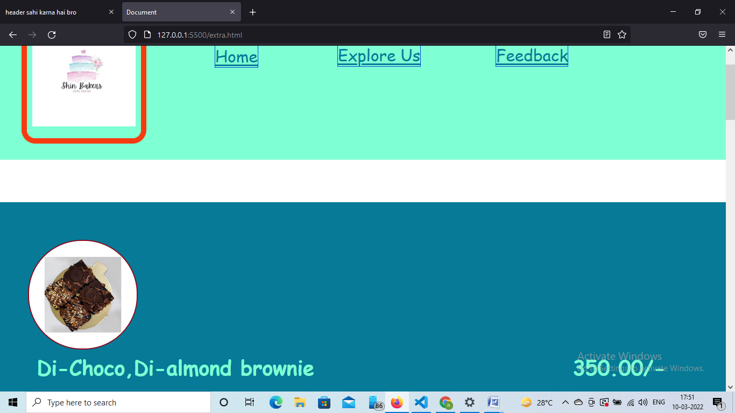

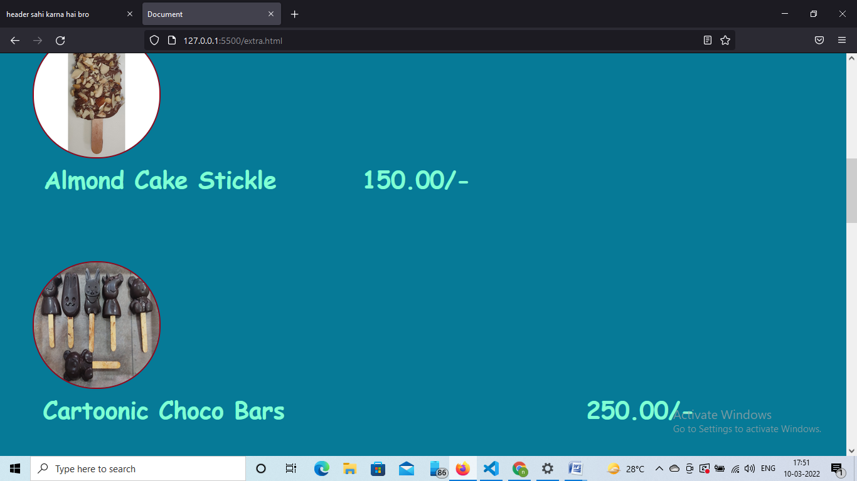

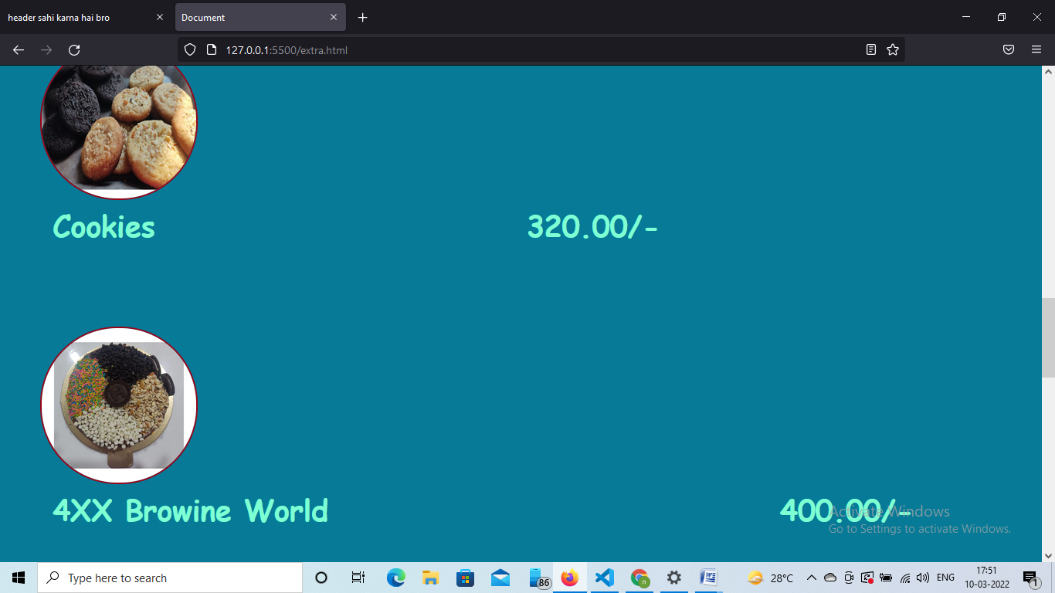

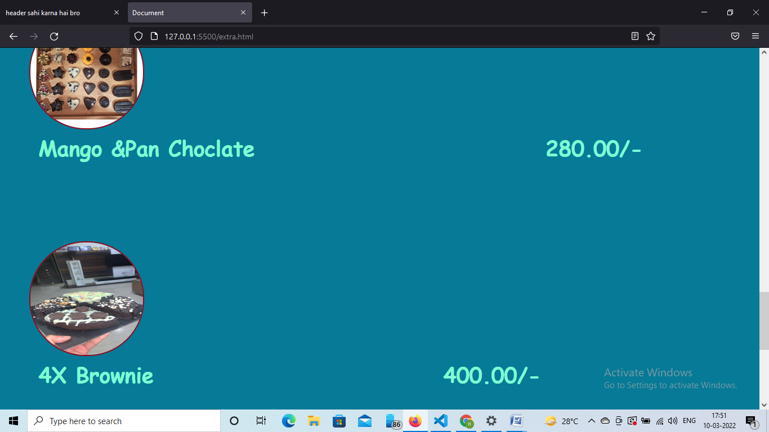

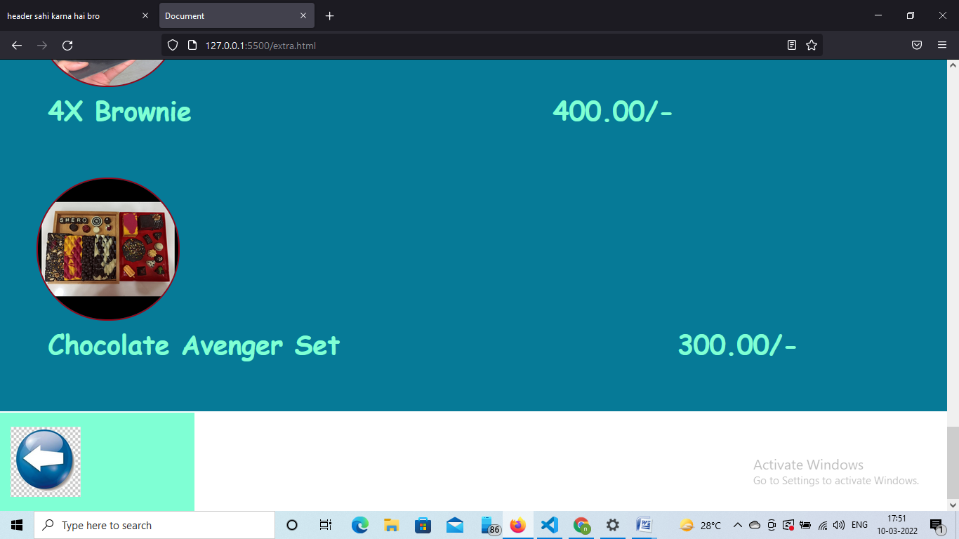

SOURCE CODE OF EXPLORE US:-

<!DOCTYPE html>

<html lang="en">

<head>

    <meta charset="UTF-8">

    <meta http-equiv="X-UA-Compatible" content="IE=edge">

    <meta name="viewport" content="width=device-width, initial-scale=1.0">

    <title>Document</title>

    <link rel="stylesheet" href="style1.css">

    <link rel="stylesheet" href="anime.css">

    <style>

        @keyframes roundi {

            from{

                border-color: yellow;

            }

            to{

                border-color: rgb(247, 51, 17);

            }

        }

          @import url('https://fonts.googleapis.com/css2?family=Lobster&display=swap');

   </style>

</head>

<body>

    <header>

        <nav>

            <ul class="logohead">

            <div>

                <li style=" border:10px solid yellow ;border-radius: 25.5px; margin:20px;padding: 10px;

                position:static;animation:roundi 5s infinite;" ><img src="img/logo.jpg" alt="LOGO" width="192px">

                </li>

            </div>

                <div> <li id="center" class="fe"><a href="page1.html"> Home </a> </li></div>

              <div><li class="fe"><a href="explore.html"> Explore Us</a> </li></div>

              <div> <li class="fe"><a href="feedback.html" >Feedback</a></li></div>

            </ul>

        </nav>

    </header>

    <main>

        <p>We use only the best ingredients to craft the perfect loaf. The perfect way to start your day.

           The quality of bread is in the details. It's sweet, it's fluffy, it's delicious.

           A bite of deliciousness.

           A little bliss in every bite.

           A slice of my life is but a piece of cake.

           All you need is love. ...

           Bakers make the world smell better.

           Birthday cake calories don't count.

           Cake is a very beautiful thing.

           Cake is always a great idea.

        what's wrong with having your cake and eating it too?</p>

        <br>

  <p>I want the best of both worlds.

I thought that's what everyone was trying to do.

give me love

give me lust

give me ***

give me hugs

what's wrong with having your cake and eating it too?

I want my lover in my best friend

and my best friend in my lover.

I have my lover

but my best friend is in another

so I'm not committed

relationships ain't for me

I'm really just trying to have my cake and eat it too.

so now I have to hurt someone again

pull the famous line, "we're better off friends", "it's not you, it's me."

but if you put cake in front of me, I'm going to try to eat it too.

isn't that what everyone would do?</p>

    </main>

    <br><br> <br>

        <footer>

            <div class="box1">

               <nbsp> <nbsp><nbsp></nbsp>TO ORDER CONTACT US AT:9987654501

                shincakes@gmail.com ..................

               FEEL FREE TO ASK ANY THING &copy;

                <div class="box2">

                  <a href="page1.html"><img src="img/button.jpg" alt="button back" width="100px" height="100px"></a>

                </div>

        </div>

        </footer>

</body>

</html>

OUTPUT OF EXPLORE US:-

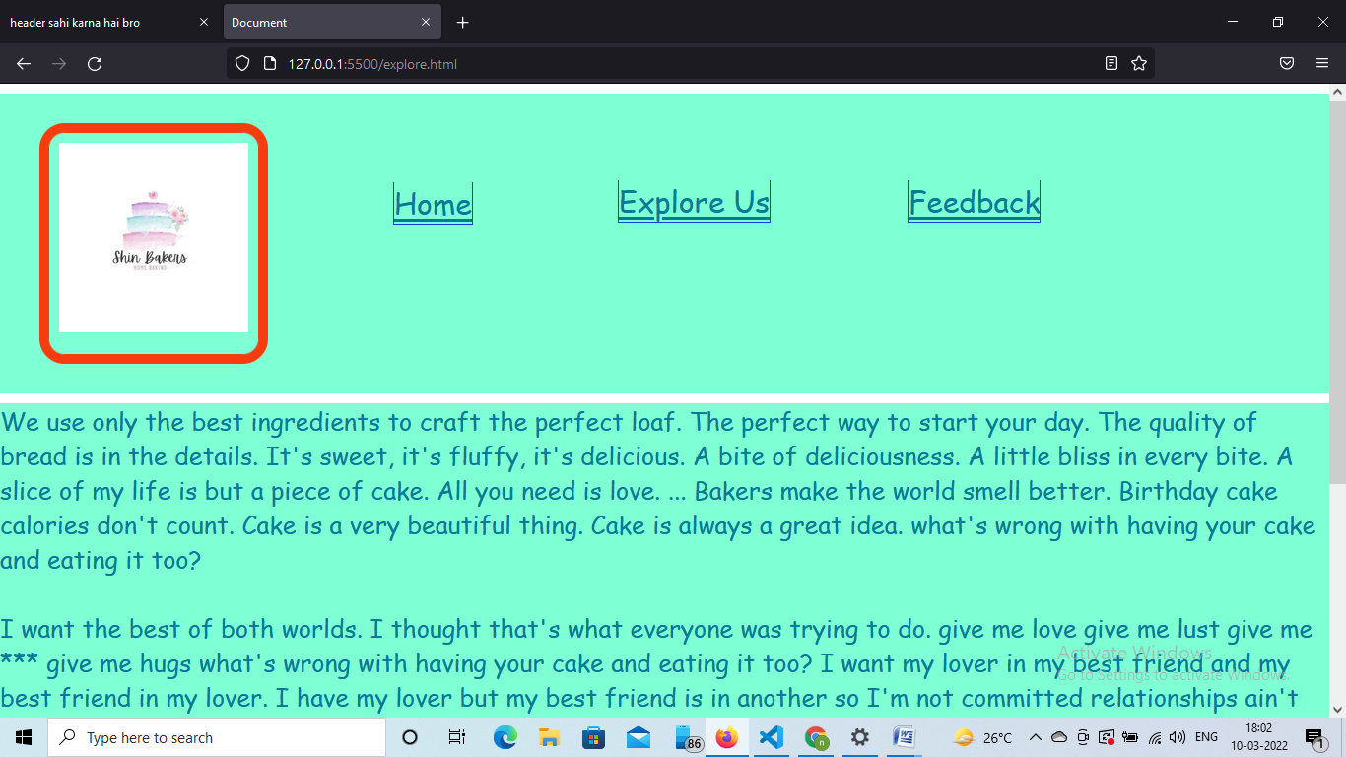

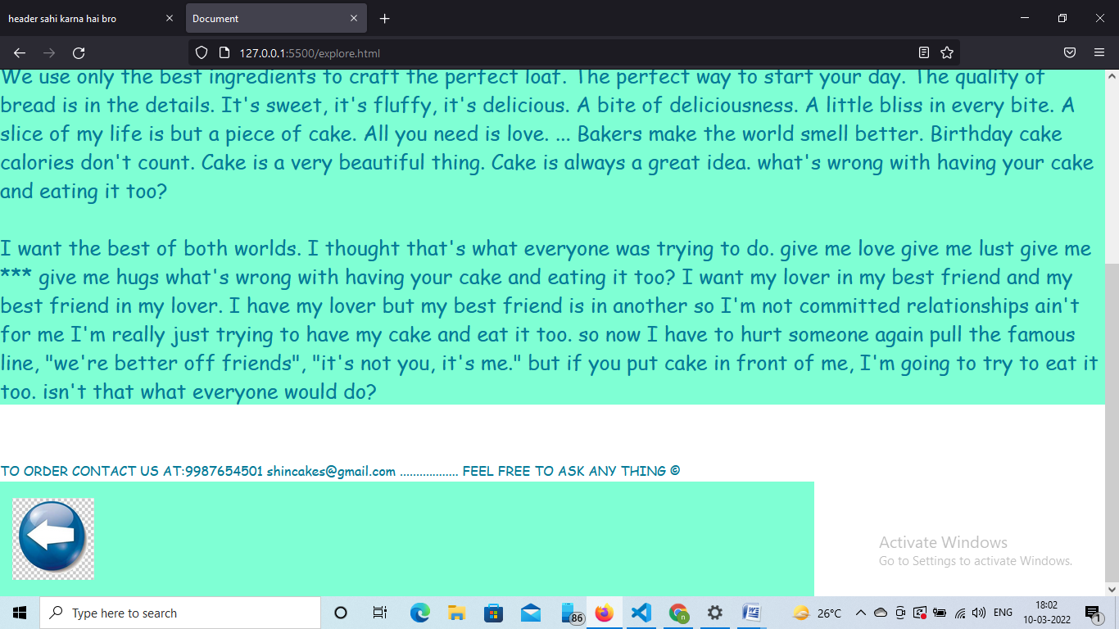

SOURCE CODE OF FEEDBACK:-

<!DOCTYPE html>

<html lang="en">

<head>

    <meta charset="UTF-8">

    <meta http-equiv="X-UA-Compatible" content="IE=edge">

    <meta name="viewport" content="width=device-width, initial-scale=1.0">

    <title>Document</title>

    <link rel="stylesheet" href="feed.css">

    <link rel="stylesheet" href="style1.css">

    <link rel="stylesheet" href="anime.css">

    <style>

        @keyframes roundi {

            from{

                border-color: yellow;

            }

            to{

                border-color: rgb(247, 51, 17);

            }

        }

          @import url('https://fonts.googleapis.com/css2?family=Lobster&display=swap');

   </style>

</head>

<body>

    <header>

        <nav>

            <ul class="logohead">

            <div>

                <li style=" border:10px solid yellow ;border-radius: 25.5px; margin:20px;padding: 10px;

                position:static;animation:roundi 5s infinite;" ><img src="img/logo.jpg" alt="LOGO" width="192px">

                </li>

            </div>

                <div> <li id="center" class="fe"><a href="page1.html"> Home </a> </li></div>

              <div><li class="fe"><a href="explore.html"> Explore Us</a> </li></div>

              <div> <li class="fe"><a href="feedback.html" >Feedback</a></li></div>

            </ul>

        </nav>

    </header>

    <div class="container">

        <form onsubmit="sendEmail(); reset(); return false;">

            <h1>Shin Cakes</h1>

            <h2>Provide us feedback in order to improve</h2>

            <input name="name" type="text" id="name" placeholder="Your Name" required>

            <br>

            <input name="email" type="email" id="email" placeholder="Your Email" required>

            <br>

            <input name="text" type="text" id="phone" placeholder="Phone no." required>

            <br>

            <textarea name="feedback" id="message" placeholder="MESSAGE" row="5" required></textarea><br>

            <button  type="submit" >Submit Feedback</button>

         </form>

     </div>

<Script src="https://smtpjs.com/v3/smtp.js"></Script>

<script>

function sendEmail(){

    Email.send({

        Host:"smtp.gmail.com",

        Username :"uppalnakul@gmail.com",

        Password :"12345678",

        To:"uppalnakul@gmail.com",

        From : document.getElementById("email").value,

        Subject:"New contact from enquiry",

        Body:"Name: "+document.getElementById("name").value+

        "<br> Email:"+document.getElementById("email")

value

        +"Phone no.:"+document.getElementById("phone").value +

        "feedback:"+document.getElementById("message").value

    }).then(message=>alert("message sent succesfully"));

}

</script>

<footer>

    <div class="box1">

        <div class="box2">

          <a href="page1.html"><img src="img/button.jpg" alt="button back" width="100px" height="100px"></a>

       </div>

</div>

</footer>

    </body>

</html>

SOURCE CODE OF FEED.CSS:-

 *{

    margin: 0;

    padding: 0;

    box-sizing: border-box;

    font-family: sans-serif;

}

.container{

    width: 100%;

    height: 100vh;

    background: aquamarine;

    display: flex;

    align-items: center;

    justify-content: center;

}

form{

    background: #fff;

    display: flex;

    flex-direction: column;

    padding: 2vw 4vw;

    width:90% ;

    max-width: 600 px;

border-radius: 10px;

}

form h3{

    color: #555;

    font-weight: 800;

    margin-bottom: 20px;

}

font input,font textarea{

    border: 0px;

    margin: 10px 0px;

    padding: 20px;

    outline: none;

    background: #f5f5f5;

    font-size: 16px;

}

form button{

    padding: 15px;

    background-color: #ff5361;

    color: #fff;

    font-size: 18px;

    border: 0;

    outline: none;

    cursor: pointer;

}

SOURCE CODE OF ANIME.CSS:-

.box1{

    background-color:whites;

    }

.box2{

    position:relative;

    top: 2px;

    height: 140px;

    width: 140px;

    background-color:aquamarine;

 animation: agge 5s infinite;

}

@keyframes agge {

        from{

            width: 240px;

        }

        to{

            width:1000px;}

}

OUTPUT OF FEEDBACK.HTML:-

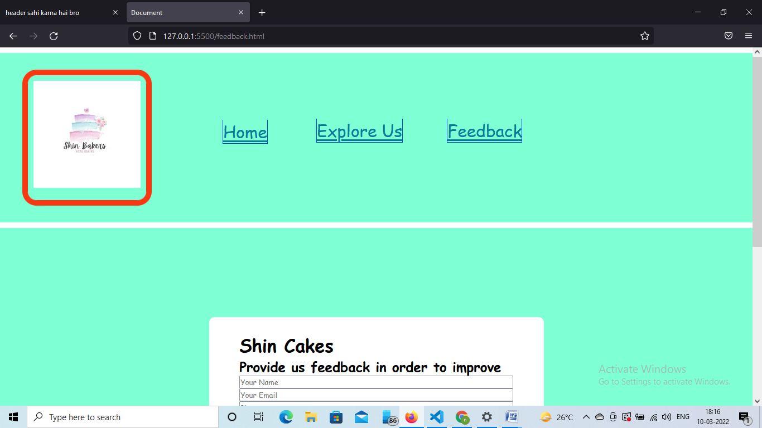

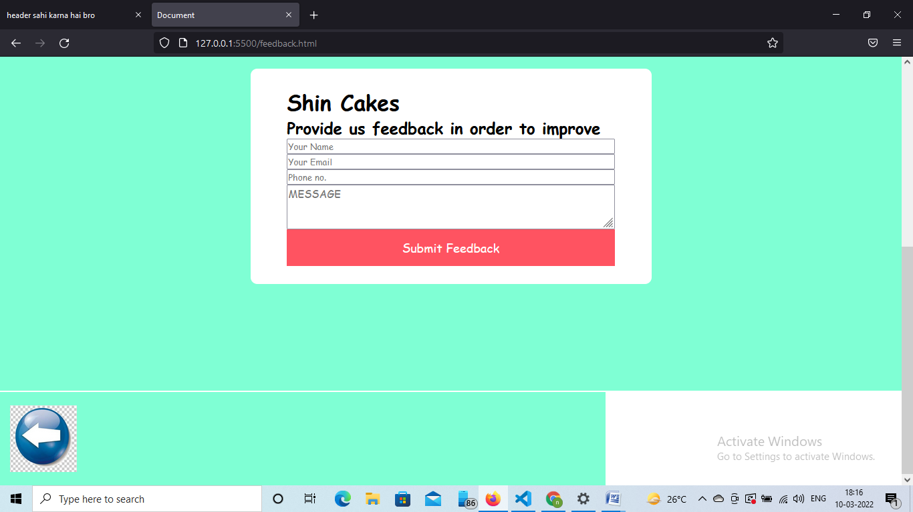

THANK

YOU